Experiment: 01

1)Create web pages using Basic HTML Tags, Table, List, Image, and Frame Tags

Experiment:

<!DOCTYPE html>

<html>

<head>

<title>EXP1</title>

</head>

<body style="background-color: lightgreen">

<center >

<a href="basic.html">BasicHTMl</a>

<br>

<br>

<a href="list.html">Lists</a>

<br>

<br>

<a href="tables.html">Tables</a>

<br>

<br>

<a href="image.html">Images</a>

<br>

<br>

<a href="frames.html">Frames</a>

<br>

<br>

</center>

</body>

</html>

Output:

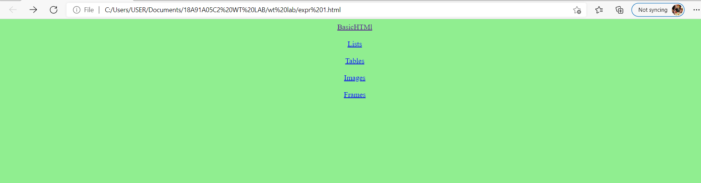

Basic HTML Tags:

<!DOCTYPE html>

<html>

<head>

<title>basic</title>

</head>

<body style="background-color:blue">

<h3 align="center">HEADING TAGS</h3>

<pre align="center">

<B >H1,H2,H3,H4,H5,H6</B>

</pre>

<h3 align="center">LIST TAGS</h3>

<b><pre align="center">

TWO TYPES

LIST

UNORDERED LIST

ORDERED LIST

</pre></b>

<h3 align="center">EDITING TAGS</h3>

<pre align="center">

<B> ITALIC </B>

<B> BOLD </B>

<B> EM </B>

<B> STRONG </B>

<B> SMALL </B>

<B> BIG </B>

</pre>

</body>

</html>

Output:

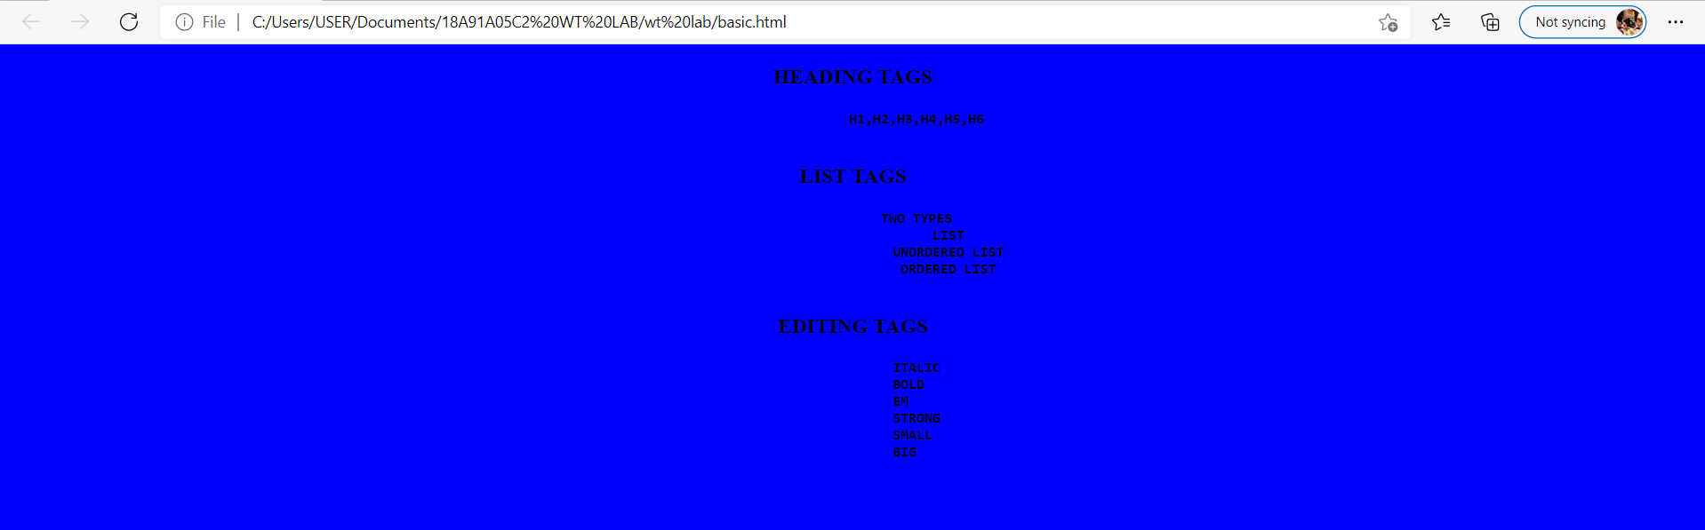

Table:

<!DOCTYPE html>

<html>

<head>

<title>tables</title>

<style type="text/css">

<td>

border: 0px;

text-align: center;

</td>

<tr>

text-align: center;

</tr>

</style>

</head>

<body bgcolor="yellow">

<center>

<h1>TIME TABLE</h1>

</center>

<table border="10 px" align="center">

<tr>

<th>Day</th>

<th>9:30 - 10:20</th>

<th>10:20 - 11:10</th>

<th>11:00 - 12:00</th>

<th>12:00 - 12:50</th>

</tr>

<tr>

<td>MONDAY</td>

<td>DMDW</td>

<td>WT</td>

<td>E.COM</td>

<td>HCI</td>

</tr>

<tr>

<td>TUESDAY</td>

<td>CN</td>

<td>WT</td>

<td>E.COM</td>

<td>HCI</td>

</tr>

<tr>

<td>WEDNESDAY</td>

<td>DMDW</td>

<td>WT</td>

<td>E.COM</td>

<td>CN</td>

</tr>

<tr>

<td>THURSDAY</td>

<td>DMDW</td>

<td>WT</td>

<td>E.COM</td>

<td>HCI</td>

</tr>

<tr>

<td>FRIDAY</td>

<td>DMDW</td>

<td>WT</td>

<td>E.COM</td>

<td>HCI</td>

</tr>

<tr>

<td>SATURDAY</td>

<td>DMDW</td>

<td>WT</td>

<td>E.COM</td>

<td>HCI</td>

</tr>

</table>

</body>

</html>

Output:

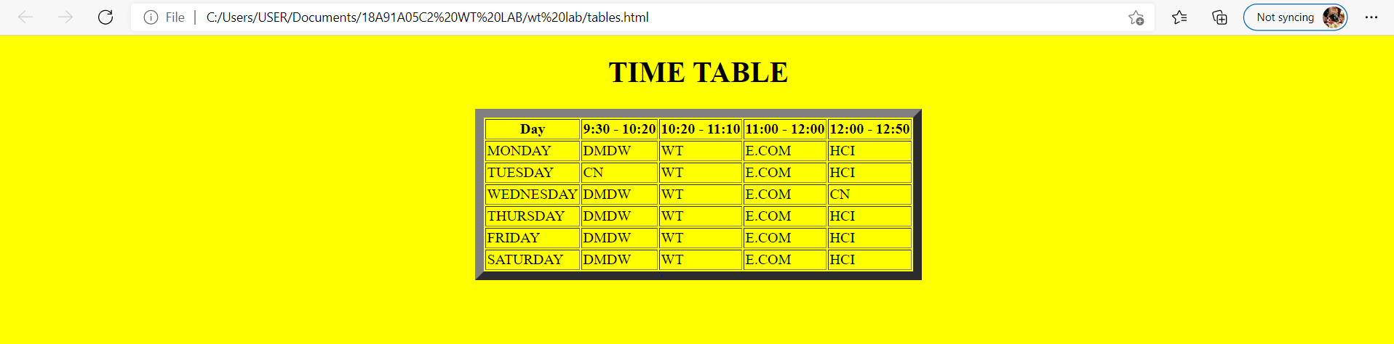

List:

<!DOCTYPE html>

<html>

<head>

<title>Lists</title>

</head>

<body style="background-color:violet ">

<h1>Unordered list</h1>

<ul type="circle"><h2>Tea</h2>

<b>

<li>WebTechnologies</li>

<li>ComputerNetwork</li>

<li>DMDW</li>

</b>

</ul>

<h1>Ordered list</h1>

<b>

<li>MACHINE LEARNING</li>

<li>RedHat</li>

<li>MEANSTACK</li>

</b>

</ol>

<h1>Definition list</h1>

<dl>

<dt>WT</dt>

<dd>Web Technologies</dd>

<dt>HTML</dt>

<dd>HyperTextMarkupLanguage</dd>

</dl>

<h1>Miscallenous list</h1>

<ul>

<li><h3>SUBJECTS</h3>

<ol>

<li>HCI</li>

<li>ECom</li>

<li>ComputerNetworks</li>

</ol>

</li>

<li><h3>PROGRAMMING LABS</h3>

<ol>

<li>C</li>

<li>CPP</li>

<li>JAVA</li>

</ol>

</li>

<li><h3>LABS</h3>

<ol>

<li>WT Lab</li>

<li>CN Lab</li>

<li>DMDW Lab</li>

</ol>

</li>

</ul>

</body>

</html>

Output:

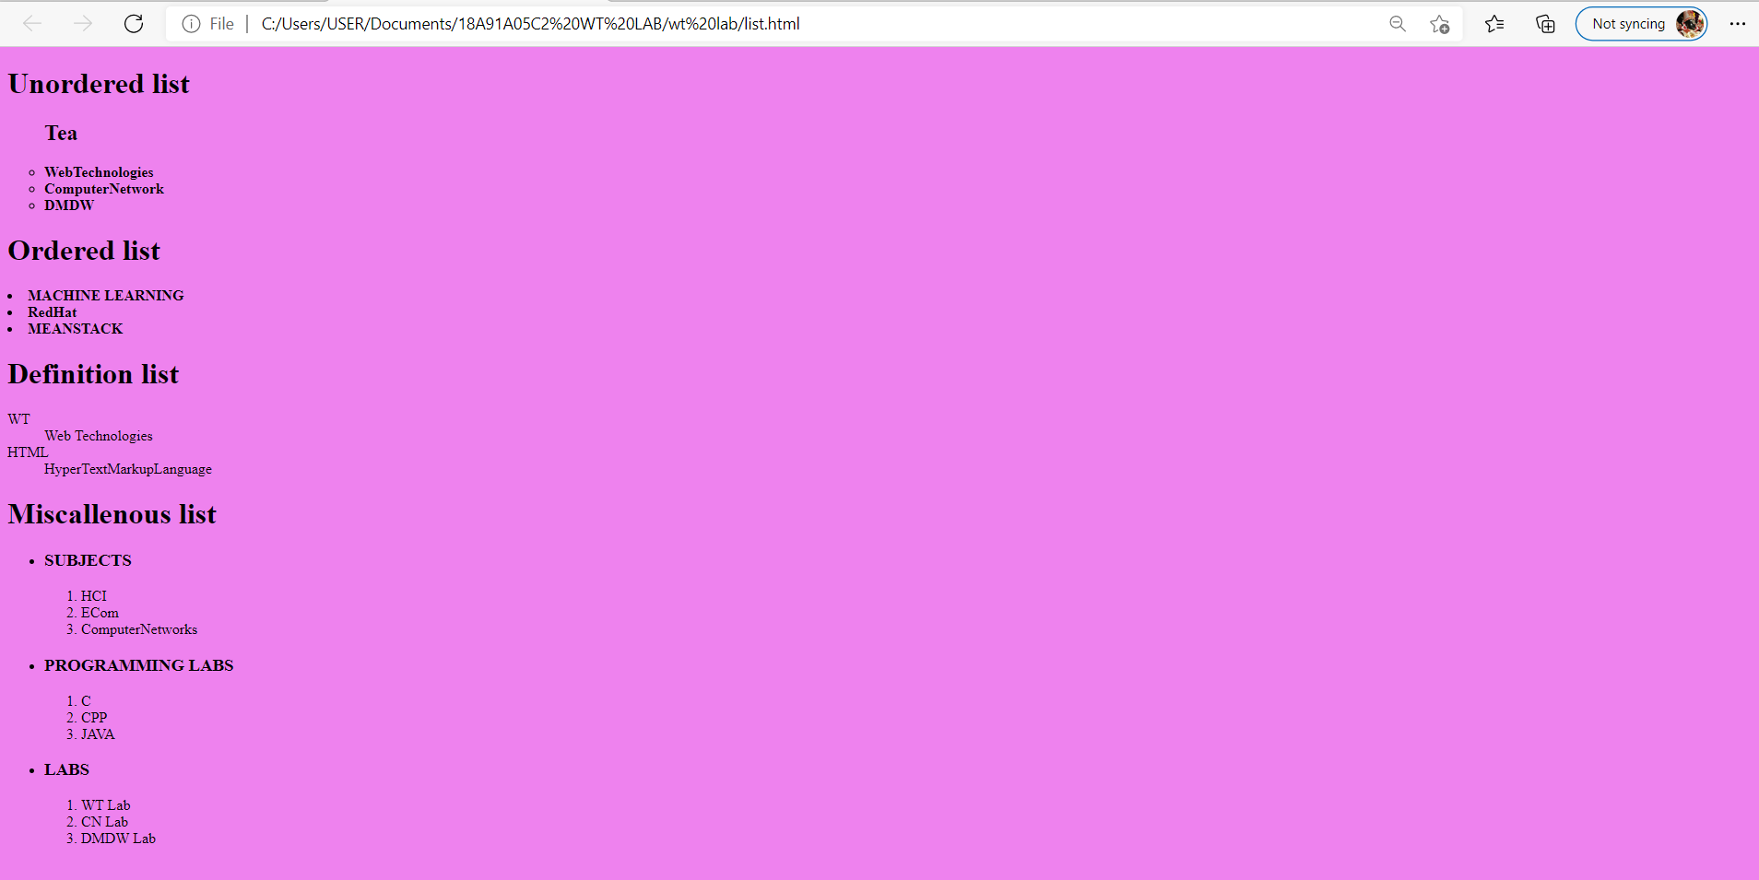

Image:

<!DOCTYPE html>

<html>

<head>

<title>Images</title>

</head>

<body bgcolor="light yellow">

<div style="height: 400px;width:100%">

<img src="krish1.JFIF" height="500px" width="25%" align="center">

</div>

<div style="height: 315px;width:100%">

<img src="krishna2.JFIF " height="300px" width="25%" align="center">

</div>

</body>

</html>

Output:

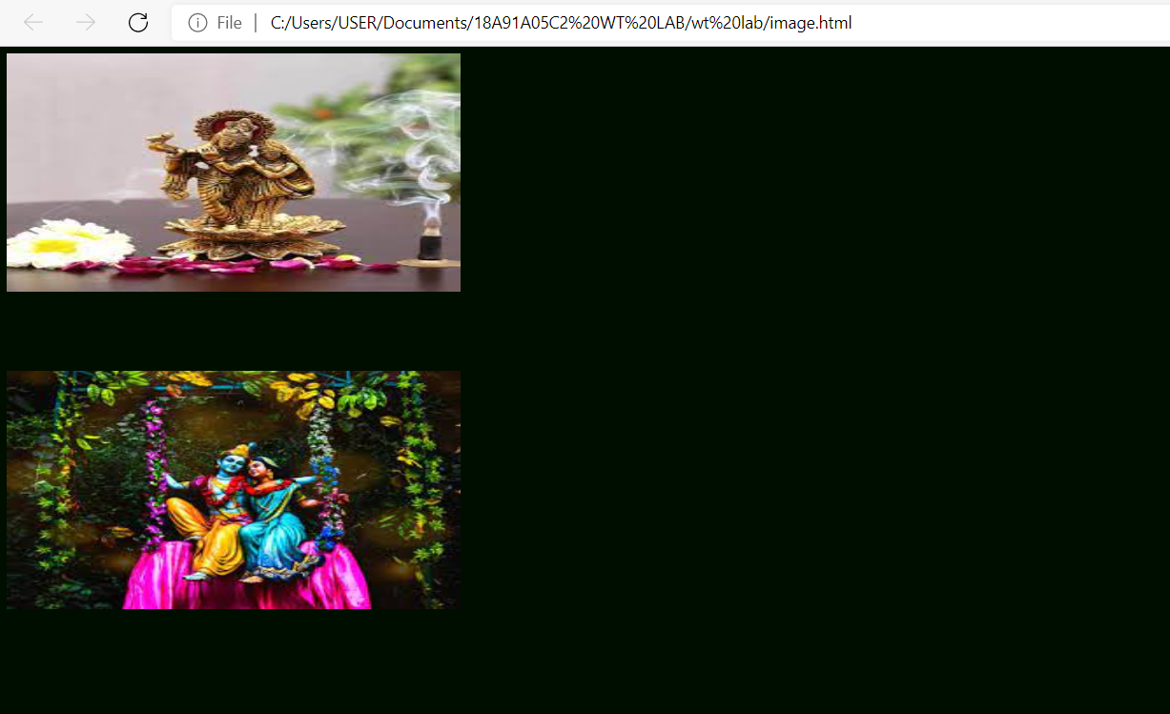

Frames:

<!DOCTYPE html>

<html>

<head>

<title>Working with Frames</title>

</head>

<frameset rows="20%,70%,10%" noresize="noresize" >

<frame style="background-color: coral" src="top.html">

</frame>

<frameset cols="20%,*">

<frame style="background-color: green" src="left.html">

<frame style="background-color: violet" src="right.html" name="rf">

</frameset>

<frame style="background-color: lightgreen" src="bottom.html">

</frame>

</frameset>

</html>

Output:

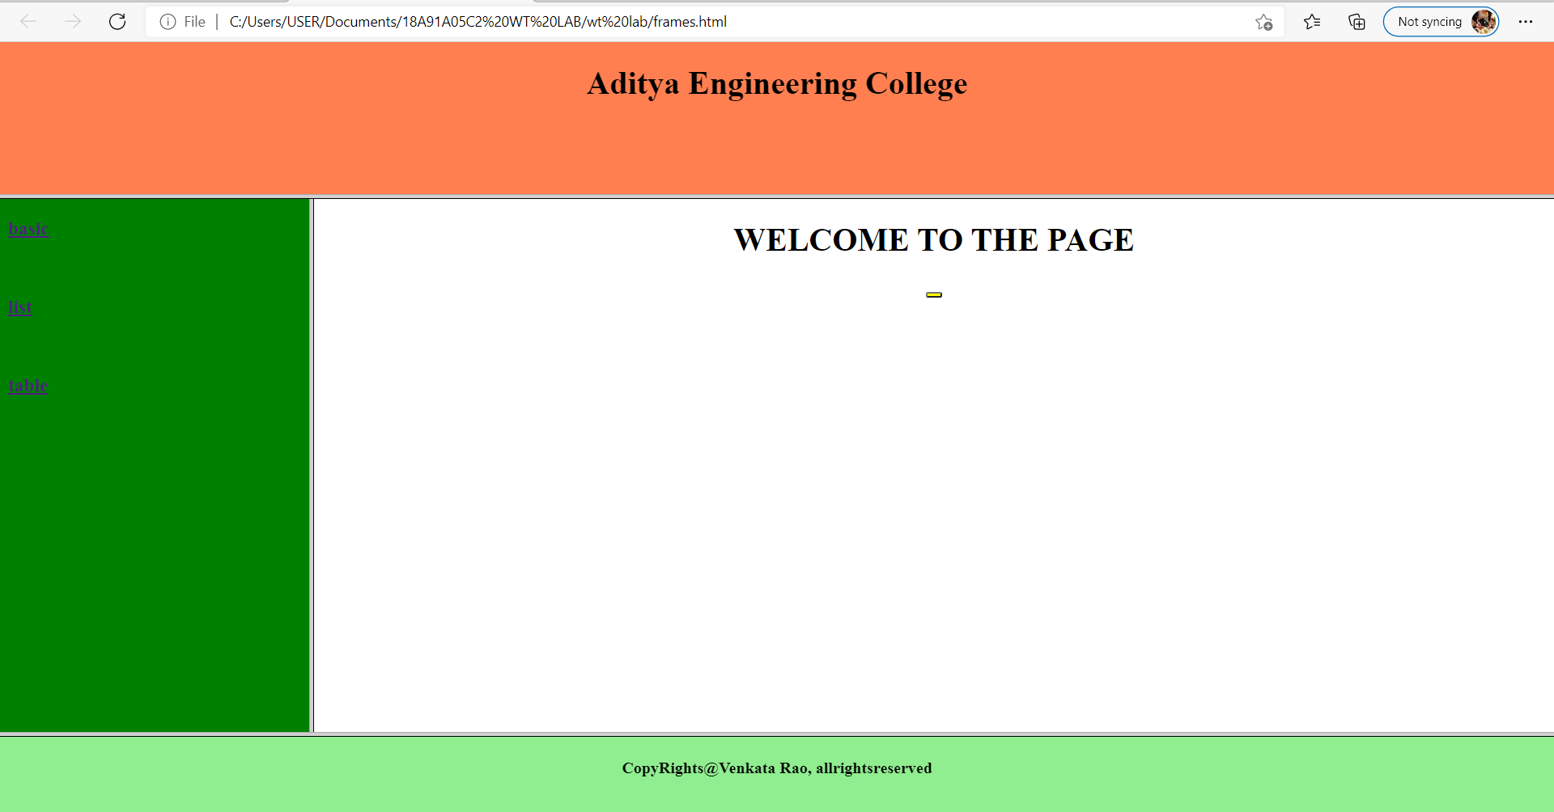

Top:

<!DOCTYPE html>

<html>

<head>

<title></title>

</head>

<body>

<h1 align="center">Aditya Engineering College</h1>

</body>

</html>

Output:

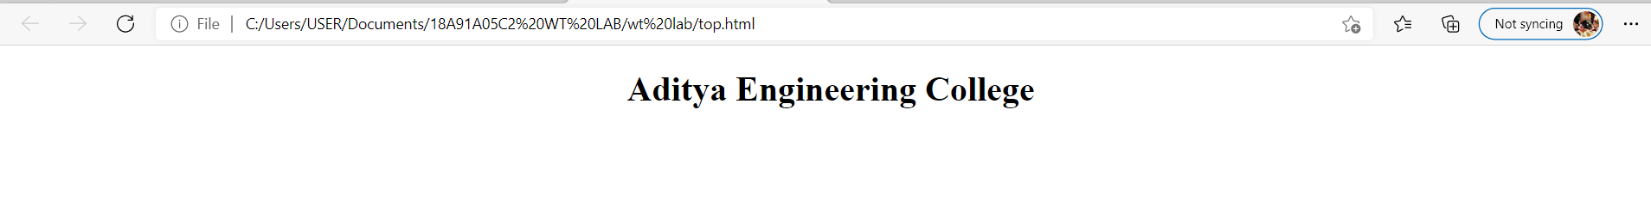

Left:

<!DOCTYPE html>

<html>

<head>

<title></title>

</head>

<body>

<h3><a href="basic.html" target="rf">basic</a></h3><br>

<h3><a href="list.html" target="rf">list</a></h3><br>

<h3><a href="tables.html" target="rf">table</a></h3><br>

</body>

</html>

Output:

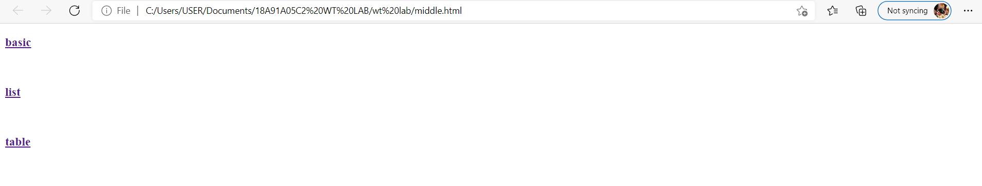

Right:

<!DOCTYPE html>

<html>

<head>

<title></title>

</head>

<body style="background-color: white">

<h1 align="center">WELCOME TO THE PAGE</h1>

</body>

</html>

Output:

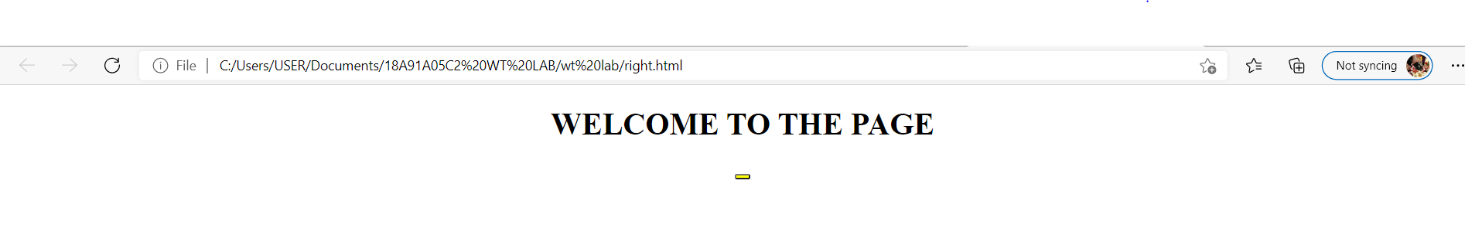

Bottom:

<!DOCTYPE html>

<html>

<head>

<title></title>

</head>

<body>

<h4 align="center">CopyRights@Venkata Rao, allrightsreserved</h4>

</body>

</html>

Output:

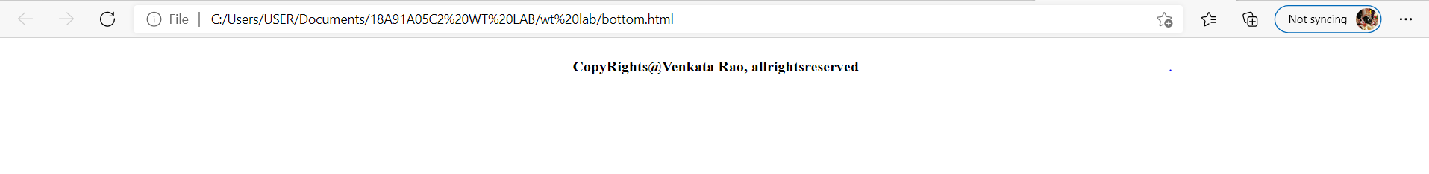

Experiment 2: Using Form Tags,

* + 1. Create a Login form
    2. Create a “registration form” with the following fields

1. Name (Text field)
2. Password (password field)
3. E-mail id (text field)
4. Phone number (text field)
5. Sex (radio button)
6. Date of birth (3 select boxes)
7. Languages known (check boxes – English, Telugu, Hindi, Tamil)
8. Address (text area)

2.1.1)Create a Login form

<html>

<head>

<title>Login page</title>

</head>

<body>

<center>

<font face="Arial Black" size="4"><u><b>LOGIN FORM</b></u></font><br><br>

<form name="f1" action="" method="post">

<table frame="box" cellspacing="10">

<tr>

<td>Login</td>

<td><input type="text" size="25"></td>

</tr>

<tr>

<td>Password</td>

<td><input type="password" size="25"></td>

</tr>

<tr>

<td colspan="2" align="center"><input type="submit" value="SUBMIT"> &nbsp;&nbsp;&nbsp;&nbsp;&nbsp;

<input type="reset" value="RESET"></td>

</tr>

</table>

</form>

</center>

</body>

</html>

Output: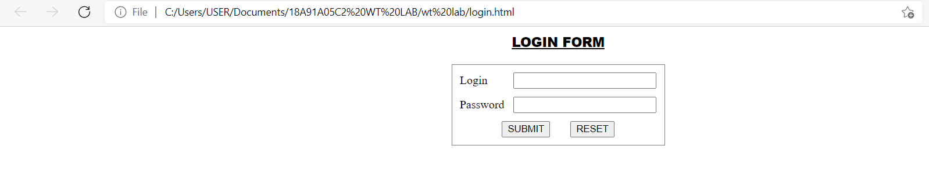

2.1.2)Create a “registration form” with the following fields

<html>

<head>

<title>Registration Page</title>

</head>

<body>

<center>

<h3 align="center"><u>REGISTRATION PAGE</u></h3>

<table border="3">

<tr>

<td><form name="f1" action="" method="post" onsubmit="">

<table cellspacing="10" cellpadding="5">

<tr><td>NAME</td><td><input type="text" size="30" name="uname"/></td></tr>

<tr><td>PASSWORD</td><td><input type="password" size="30" name="pass"/></td></tr>

<tr><td>E-MAIL ID</td><td><input type="text" size="30" name="email"/></td></tr>

<tr>

<td> PHONE NUMBER</td><td><input type="text" size="15" name="phone"/></td></tr>

<tr>

<td>GENDER</td>

<td><input type="radio" name="gen" value="m" />MALE <input type="radio" name="gen"

value="f" />FEMALE </td>

</tr>

<tr><td>DATE OF BIRTH</td>

<td><select name="day">

<option value="day">DAY</option>

<option value="1">1</option>

<option value="2">2</option>

<option value="3">3</option>

<option value="4">4</option>

<option value="5">5</option>

<option value="6">6</option>

<option value="7">7</option>

<option value="8">8</option>

<option value="9">9</option>

<option value="10">10</option>

<option value="11">11</option>

<option value="12">12</option>

<option value="13">13</option>

<option value="14">14</option>

<option value="15">15</option>

<option value="16">16</option>

<option value="17">17</option>

<option value="18">18</option>

<option value="19">19</option>

<option value="20">20</option>

<option value="21">21</option>

<option value="22">22</option>

<option value="23">23</option>

<option value="24">24</option>

<option value="25">25</option>

<option value="26">26</option>

<option value="27">27</option>

<option value="28">28</option>

<option value="29">29</option>

<option value="30">30</option>

<option value="31">31</option>

</select>

<select name="month">

<option value="month">MONTH</option>

<option value="jan">JANUARY</option>

<option value="feb">FEBRUARY</option>

<option value="mar">MARCH</option>

<option value="apr">APRIL</option>

<option value="may">MAY</option>

<option value="jun">JUNE</option>

<option value="jul">JULY</option>

<option value="aug">AUGUST</option>

<option value="sep">SEPTEMBER</option>

<option value="oct">OCTOBER</option>

<option value="nov">NOVEMBER</option>

<option value="dec">DECEMBER</option>

</select>

<select name="year">

<option value="year">YEAR</option>

<option value="1986">1986</option>

<option value="1987">1987</option>

<option value="1988">1988</option>

<option value="1989">1989</option>

<option value="1990">1990</option>

<option value="1991">1991</option>

<option value="1992">1992</option>

<option value="1993">1993</option>

<option value="1994">1994</option>

<option value="1995">1995</option>

<option value="1996">1996</option>

<option value="1997">1997</option>

<option value="1998">1998</option>

<option value="1999">1999</option>

<option value="2000">2000</option>

<option value="2001">2001</option>

<option value="2002">2002</option>

<option value="2003">2003</option>

<option value="2004">2004</option>

<option value="2005">2005</option>

<option value="2006">2006</option>

<option value="2007">2007</option>

<option value="2008">2008</option>

<option value="2009">2009</option>

<option value="2010">2010</option>

<option value="2011">1980</option>

<option value="2012">1981</option>

<option value="2013">1982</option>

<option value="2014">1983</option>

</select></td></tr>

<tr><td>LANGUAGES KNOWN</td>

<td><input type="checkbox" value="eng" name="lang" />ENGLISH

<input type="checkbox" value="tel" name="lang" />TELUGU

<input type="checkbox" value="hin" name="lang" />HINDI

<input type="checkbox" value="tam" name="lang" />TAMIL

</td></tr>

<tr>

<td>ADDRESS</td>

<td><textarea name="addr" cols="25" rows="5"></textarea></td>

</tr>

<tr><td colspan="2" align="center"><input type="submit" value="SUBMIT"/> &nbsp;&nbsp;&nbsp;&nbsp;&nbsp;&nbsp;<input type="reset" value="RESET" /></td>

</tr>

</table>

</form>

</td>

</tr>

</table>

</center>

</body>

</html>

Output:

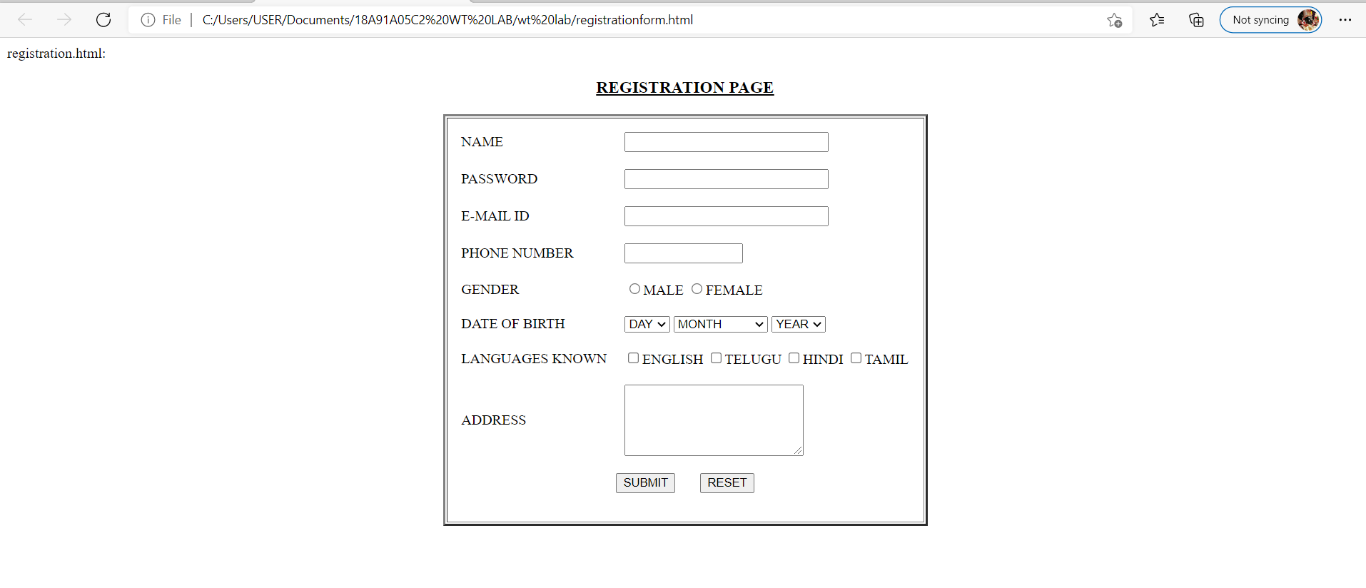

**Experiment 3:**

* 1. Design a web page using CSS (Cascading Style Sheets) which includes the following:

3.1.1) Use different font, styles: In the style definition you define how each selector should work (font,

color etc). Then, in the body of your pages, you refer to these selectors to activate the styles.

* + 1. Set a background image for the web page and control the repetition of the image with the background-repeat property.
    2. Define styles for link as visited, active, hover & link.

**styles.css**

h1

{ color:red;

font-family:caStellar; font-size:22pt;

text-decoration:underline;

}

h2

{ color:blue;

font-family:Chiller; font-size:18pt;

text-decoration:overline;

}

p

{ color:magenta;

font-family:Trebuchet MS; font-size:14pt;

font-style:italic;

}

**fontstyles.html**

<html>

<head>

<title>Usage of different font,styles and colors </title>

<link rel="stylesheet" type="text/css" href="styles.css"/>

</head>

<body>

<h1>This header is in red</h1>

<h2>This header is in blue</h2>

<p>This is normal text</p>

</body>

</html>

Output:

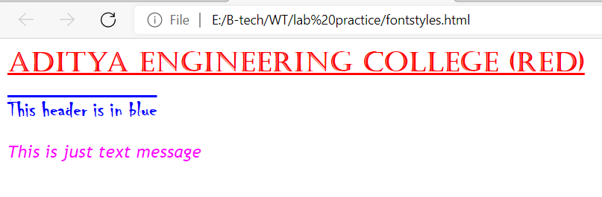

**3.1.2) Set a background image for the web page and control the repetition of the image with the background-repeat property.**

backgroundimage.html

<html>

<head>

<title>Controlling background image</title>

<style type="text/css">

body

{

background-image:url("img11.jpg");

background-repeat:no-repeat

}

</style>

</head>

<body text="#fe78a2">

<h1>Life is beautiful!!!</h1>

</body>

</html>

**OUTPUT:**



**3.1.3) Define styles for link as visited, active, hover & link**.

<html>

<head> <h1 align=center> Web Page using CSS </h1>

<style type="text/css">

body{background-image:url(pexel1.jpg); background-repeat:repeat-y;}

p{color:aqua;font-size:20pt;font-family:chiller;background-image:url(img1.jpg);}

a:link{font-size:20pt;background-color:white;}

a:hover{font-size:20pt;background-color:yellow;cursor:crosshair;}

a:active{font-size:20pt;background-color:cyan;cursor:help;}

a:visited

{

font-size:20pt;background-color:blink;

}

</style>

</head>

<title> CSS Webpage!!! </title>

<body>

<br>

<p> Weclome to Web page using CSS where CSS means Cascading Style Sheets! using CSS we can apply the common styles to different tags and also different

styles to same tag i.e. repeated more than once in the html file </p>

<a href="form(registration).html"><center> Register </center></a>

<br><br><br><br><br><br><br><br><br>

</body>

</html>

**OUTPUT:**

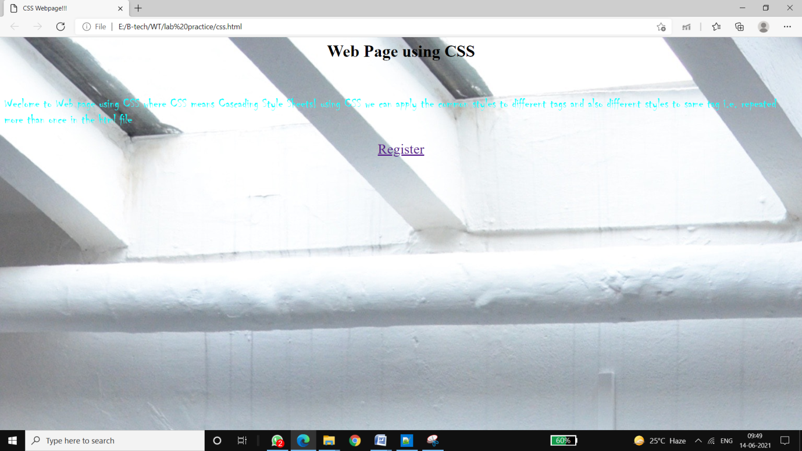

**3.2) Write a JavaScript that takes a number from one text field in the range of 0-999 and display it in other text field in words. If the number is out of range, it should show “out of range” and if it is not a number, it should show “not a number” message in the result box.**

<!DOCTYPE html>

<html>

<head>

<meta charset="utf-8">

<title></title>

<script language="javascript">

function convert_number_to_words(number)

{

hyphen='-';

conjunction='and';

separator='.';

dictionary={0:'zero',1:'one',2:'two',3:'three',4:'four',5:'five',6:'six',7:'seven',8:'eight',

9:'nine',10:'ten',11:'eleven',12:'twelve',13:'thirteen',14:'fourteen',15:'fifteen',16:'sixteen',

17:'seventeen',18:'eighteen',19:'nineteen',20:'twenty',30:'thirty',40:'fourty',50:'fifty',

60:'sixty',70:'seventy',80:'eighty',90:'ninety',100:'hundred',};

if(number<0 || number>999)

{

alert("enter a number range between 0 and 999");

return "";

}

switch(true)

{

case(number<21):

string=dictionary[number];

break;

case(number<100):

tens=parseInt(number/10)*10;

units=number%10;

string=dictionary[tens];

if(units){

string+=hyphen+dictionary[units];

}

break;

case(number<1000):

hundreds=parseInt(number/100);

remainder=number%100;

string=dictionary[hundreds]+ ' ' +dictionary[100];

if(remainder){

string+=conjunction+convert_number_to_words(remainder);

}

break;

default:

break;

}

return string;

}a=prompt("Enter a number");

num=parseInt(a);

document.write(convert_number_to_words(num));

</script>

</head>

<body bgcolor="aqua">

<h2 align="center"><i>WELCOME TO JAVASCRIPT</i></h1>

</body>

</html>

**OUTPUT:**

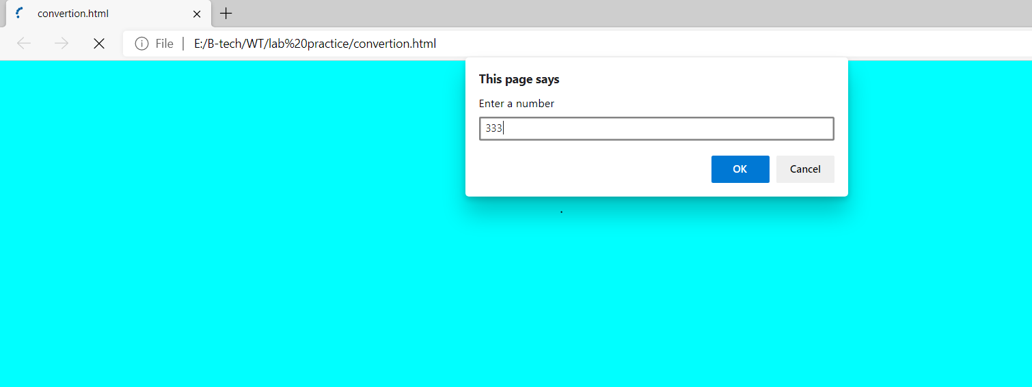

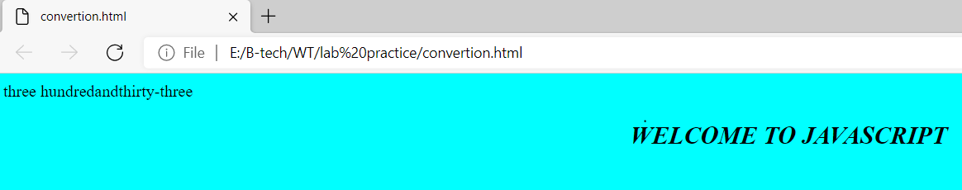

**4) Java Script & XML**

**4.1) Write a JavaScript to validate the following fields in a registration page created in week 2**

**a. Name (start with alphabet and followed by alphanumeric and the length should not be less than 6 characters)**

**b. Password (it allows alphanumeric, special symbols and should not be less than 6 characters)**

**c. E-mail (should not contain invalid email addresses)**

<html>

<head> <h1 align=center>Welcome to Validation Checking</h1><hr width=50%>

<script language="javascript">

function validation()

{

var x=f.un.value; var len=x.length; var val=x.charCodeAt(0); var p=f.pw.value; var c=f.cpw.value; var a=f.email.value; var atpos=a.indexOf("@"); var dotpos=a.lastIndexOf("."); if(len<6 || x=='' || x==null)

{

alert("check your username! must be minimum 6 characters"); if(val<65 || val>90 && val <97 || val>122) alert("username must begin with an alphabet"); return false;

}

else if(val<65 || val>90 && val <97 || val>122)

{

alert("username must begin with an alphabet"); return false;

}

else if(p=='' || c=='' || p.length<6 || c.length<6 || p!=c)

{

alert("Password and Confirm Password should be same and greater than 6 characters!"); return false;

}

else if(atpos<6 || dotpos<atpos+6 || dotpos+2>=a.length)

{

alert("Not a valid email id"); return false;

}

else

alert("Congragulations! you have submited successfully");

}

</script>

</head>

<title> Validation Check! </title>

<body>

<table align=center>

<form name="f" action="success.html" onsubmit="return validation();" method="post">

<tr><td>User Name:</td><td><input type="text" name="un"/></td></tr>

<tr><td>Password:</td><td><input type="password" name="pw"/></td></tr>

<tr><td>Confirm Password:</td><td><input type="password" name="cpw"/></td></tr>

<tr><td>E-mail ID:</td><td><input type="text" name="email"/></td></tr>

<tr><td></td><td><input type="submit" value="Submit"/></td></tr>

</form></table>

</body>

</html>

**OUTPUT:**

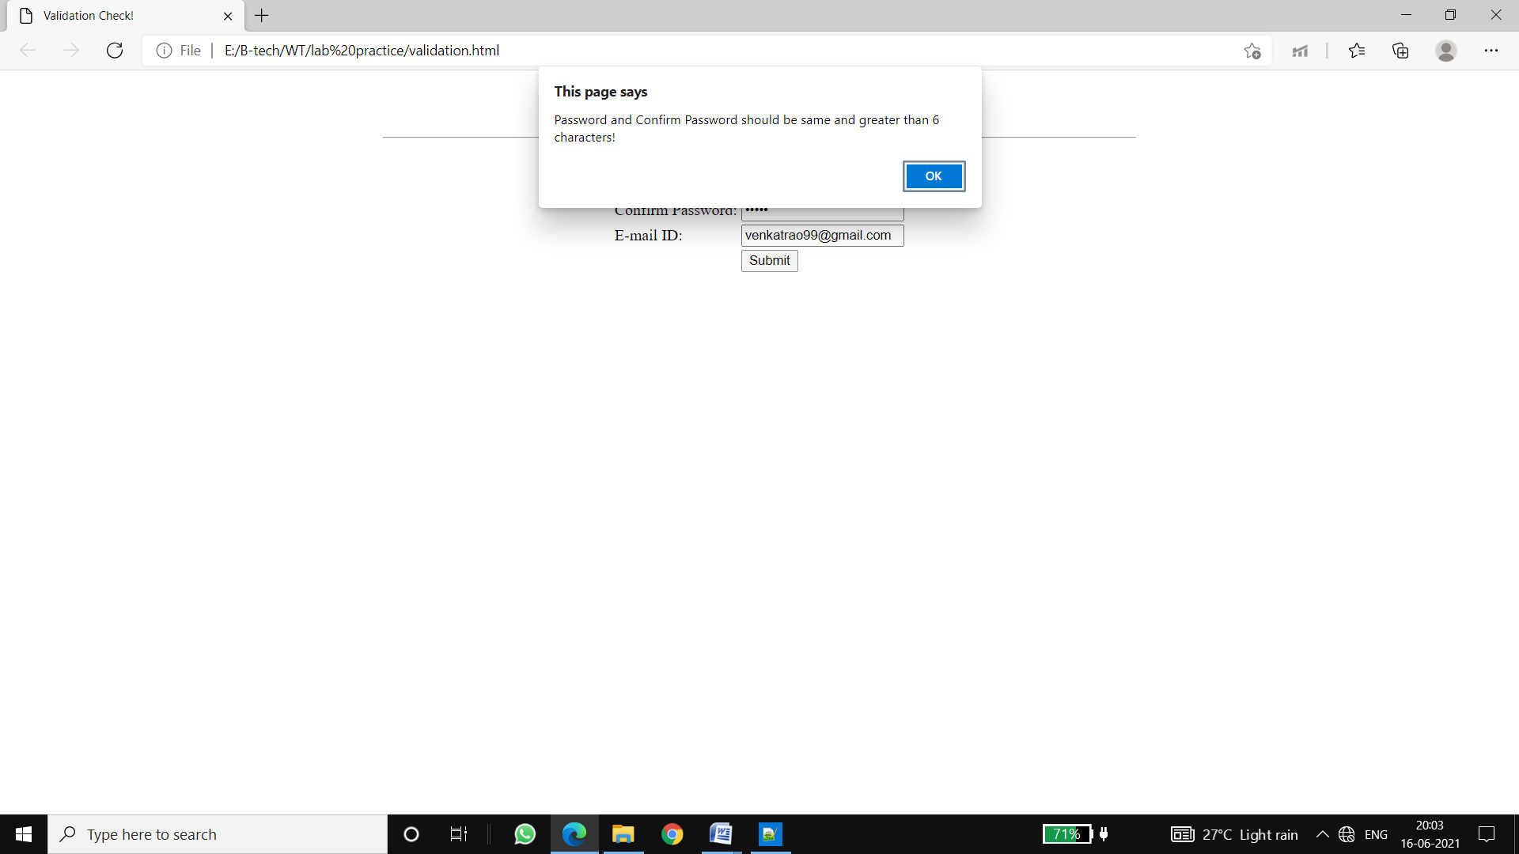

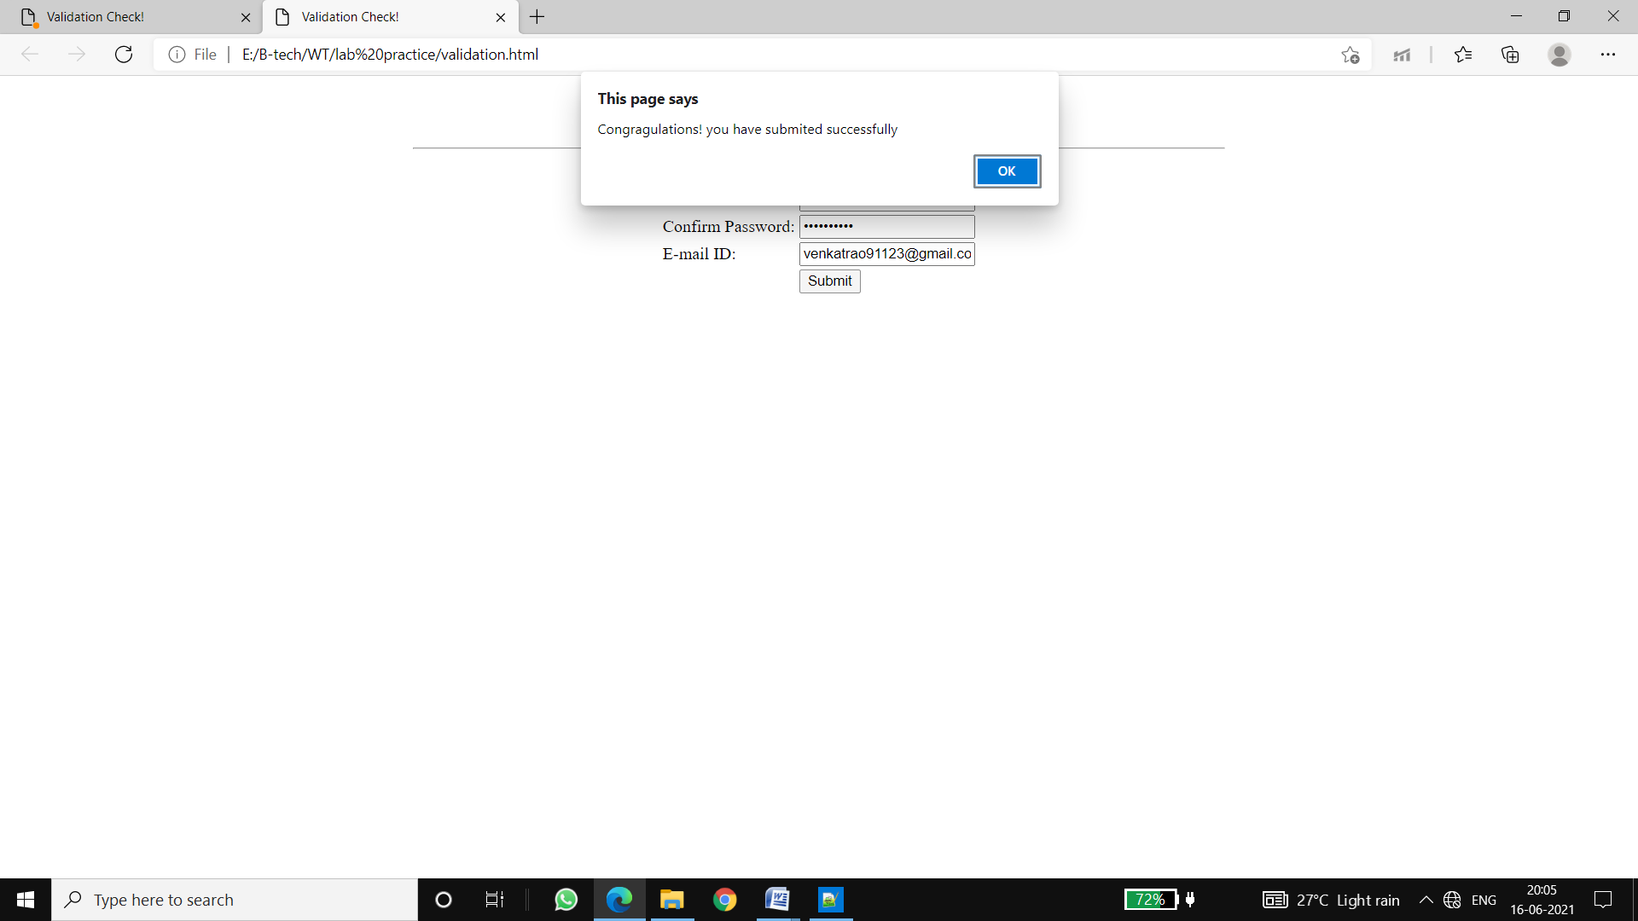

* 1. Write an XML file which will display the Book information which includes the following:

a) Title of the book

b) Author Name

c) ISBN number

d) Publisher name

e) Edition

f) Price

Write a Document Type Definition (DTD) to validate the above XML file and display the details in a table (to do this use XSL).

**book.dtd:**

<!ELEMENT bookdetails (books+)>

<!ELEMENT books (title,author,isbn,publisher,edition,price)>

<!ELEMENT title (#PCDATA)>

<!ELEMENT author (#PCDATA)>

<!ELEMENT isbn (#PCDATA)

<!ELEMENT publisher (#PCDATA)

<!ELEMENT edition (#PCDATA)>

<!ELEMENT price (#PCDATA)>

**book.xml:**

<?xml version="1.0"?>

<!DOCTYPE bookdetails SYSTEM "book.dtd">

<?xml:stylesheet type="text/xsl" href="book.xsl"?>

<bookdetails>

<books>

<title> C </title>

<author> Balaguruswamy </author>

<isbn> 123456</isbn>

<publisher>Oxford</publisher>

<edition> Edition-II </edition>

<price>$30.00</price>

</books>

<books>

<title> C++ </title>

<author> yaswanth kanethkar </author>

<isbn>654321</isbn>

<publisher>Tata McHill</publisher>

<edition> Edition-I </edition>

<price>$35.00</price>

</books>

<books>

<title> JAVA </title>

<author> Herbert Schildt </author>

<isbn>789456</isbn>

<publisher>Cenage</publisher>

<edition> Edition-IV </edition>

<price>$50.00</price>

</books> </bookdetails>

**book.xsl:**

<?xml version="1.0"?>

<xsl:stylesheet version="2.0" xmlns:xsl="http://www.w3.org/1999/XSL/Transform">

<xsl:template match="/">

<html>

<head> <center>Book Details</center> </head>

<body>

<hr width="50%"/>

<table border="1" align="center">

<tr>

<th> TITLE </th>

<th> AUTHOR </th>

<th>ISBN</th>

<th>PUBLISHER</th>

<th> EDITON </th>

<th> PRICE </th>

</tr>

<xsl:for-each select="bookdetails/books">

<tr>

<td> <xsl:value-of select="title"/></td>

<td> <xsl:value-of select="author"/></td>

<td> <xsl:value-of select="isbn"/></td>

<td> <xsl:value-of select="publisher"/></td>

<td> <xsl:value-of select="edition"/></td>

<td> <xsl:value-of select="price"/></td>

</tr>

</xsl:for-each>

</table>

</body>

</html>

</xsl:template>

</xsl:stylesheet>

Output:

